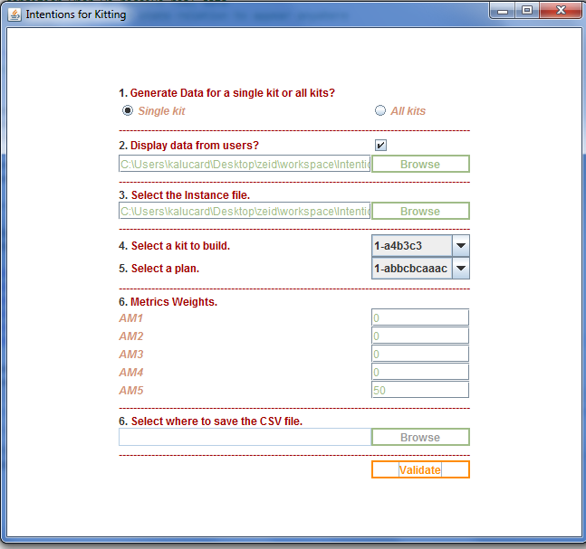

New feature: Ability to display data from users

1. Select “Single Kit”
2. Check the box next to “2. Display data from users?”
3. Browse to the csv file (this is the one you sent to me). This file is in the same directory under the name “user-data.csv”
4. Select the owl instance file. This file is in the same directory under the name “kittingInstances_ir.owl”
5. Select the kit you want to build and the associated plan
6. Set the metrics weights
7. Click “Validate”

The results look like the ones displayed in the picture below

* “Algorithm” is the data computed by the algorithm
* “User” is about the data from the users

NOTE: If you have some issues, try to delete the config.ini file and restart the tool.

NOTE: I need to display the metrics charts for both data (algorithm and users). It’s under the tab “Metrics”. As of now I only have metrics data from the algorithm. I will work on displaying the charts from the users’ data later.

